D804 Advanced AI for Computer Scientists
Robert Kuprenas
Student ID: 012611549
Part 1
____________________________________________________________________________________
A. GitLab Repository History Screenshot
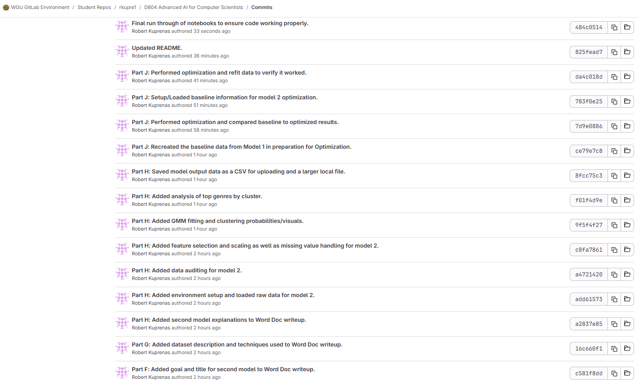
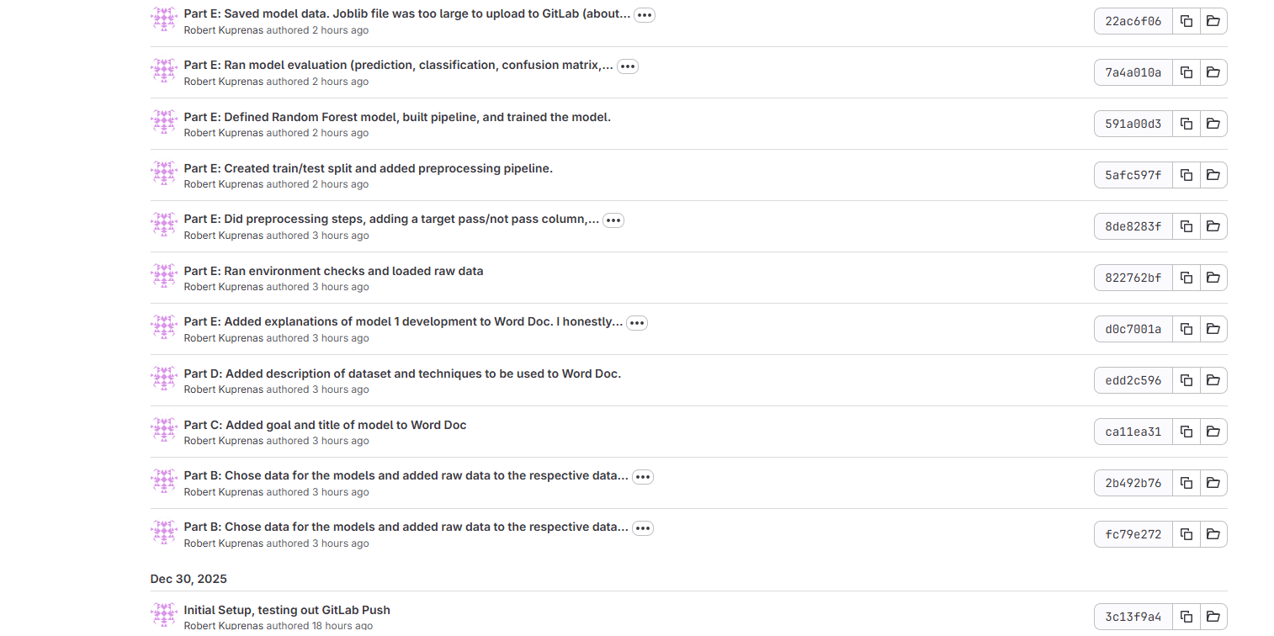
____________________________________________________________________________________
B. Choose one dataset from an open source for each of your models.
Dataset for Model 1:
exam_score_prediction.csv
Source: https://www.kaggle.com/datasets/kundanbedmutha/exam-score-prediction-dataset

Dataset for Model 2:
vgsales.csv
Source: https://www.kaggle.com/datasets/gregorut/videogamesales

____________________________________________________________________________________
C. Identify the goal of the first model, including the name of the model using the format “D804_PA_Model_Title” where “Title” is the name you have chosen the model.
Title: D804_PA_Exam_Success_Prediction
Goal: Design an AI Model to analyze quantity and quality of sleep, gender, and hours studied in order to predict passing exams with a score greater than or equal to 60%.

____________________________________________________________________________________
D. Identify the dataset to be used for the first model.
1. Describe the dataset and its features.
The data set includes 20,000 rows of information about students that have taken exams. Features included in the raw data include: age, gender, sleep quantity/quality, hours studied, course, difficulty of test, facility rating, and study method. Target of exam score is also included in the data.

2. Explain why you chose this dataset.
I have worked in the education field for 16 years, so I have a lot of experience with learners and standardized testing. I’m curious to see if there is any correlation between the amount and quality of sleep a student gets and how well they do on the exam. I am also going to include hours of study and gender for more data analysis.

3. Describe the technique(s) used to prepare the data for modeling.
Since I am only focusing on 4 features, the data will be cleaned to remove all other feature columns. The test score column will also remain. Additionally, I will add a column of labels for whether the score was greater than or equal to 60, as this is the cutoff I will use to determine “passing”. Passing will be set to 1, and not passing will be set to 0.
All available records were retained, as the dataset size is small enough for efficient processing on a standard CPU. Categorical variables were encoded using one-hot encoding.

____________________________________________________________________________________
E. Develop the first model using any of the advanced methods from the course, identifying which method you chose.
1. Explain how the model was developed.
I started by setting up my IDE, installing libraries and tools needed for the model. Next, I loaded the raw data and implemented preprocessing techniques to clean the data and get it ready for training. Once the data was cleaned and prepared for training, the training steps were ready to begin.

2. Explain how the model was trained to accomplish its task.
For training, the data was split into training and testing data, using an 80/20 split. Since labels were added, I used a Random Forest to model complex interactions between sleep quality, study habits, and exam performance. “Random Forest is a widely used ensemble classification algorithm that can handle nonlinear interactions and complex feature patterns while providing robust performance on moderately sized datasets” (Silvey, 2024).

3. Explain how the results were validated for the model’s performance.
I added accuracy, precision, recall, and F1-score metrics to see how the model performed. I also added a confusion matrix and a plot to help visualize how well the model did at predicting passing scores based on gender, study hours, and sleep.

4. Explain how the model could be deployed to end users.
If the model is optimized to give accurate predictions consistently, it could be used to give guidance on the ideal amount of sleep for successful testing based on gender. It can also give guidance on how useful studying is when it is at the expense of quality sleep. This would be useful information for school districts, educational government agencies, and students/families. Deployment could take place through cloud services, websites, or apps that education workers could use with their students.

5. Document the code for submission to GitLab.
All code, datasets, and documentation were committed to a GitLab repository with version control, including a README file describing setup, execution steps, and model configuration.
____________________________________________________________________________________
F. Identify the goal of the second model, including the name of the model using the format “D804_PA_Model_Title” where “Title” is the name you have chosen for the model.
Title: D804_PA_Videogame_Sales_Prediction
Goal: Identify probabilistic groupings of video games based on release year and global sales, with genre used for post-cluster interpretation of sales patterns.

____________________________________________________________________________________
G. Identify the dataset to be used for the second model.
1. Describe the dataset and its features.
The raw dataset includes the following features: name of game, platform, release year, genre, publisher, and sales by world regions. The target is also included in a total global sales column. There are over 16,000 rows of data in the raw dataset.

2. Explain why you chose this dataset.
I enjoy playing videogames, and I have a dream of making a successful videogame app. Seeing what types of games were the most financially successful will help me focus my efforts when I begin creating games for others to play.

3. Describe the technique(s) used to prepare the data for modeling.
Since I am only focusing on 2 numeric features, the data was cleaned to remove all other feature columns. The global sales column also remained. No labels were added, as the model uses unsupervised probabilistic learning to identify natural groupings in the data.
All available records were retained, as the dataset size is small enough for efficient processing on a standard CPU.
____________________________________________________________________________________
H. Develop the second model using any of the probabilistic methods from the course, identifying which method you chose.
1. Explain how the model was developed.
A Gaussian Mixture Model was selected to probabilistically cluster video games based on release year and global sales, allowing each game to belong to clusters with varying likelihoods. “A Gaussian Mixture Model (GMM) is a probabilistic method that assumes data points are generated from a mixture of normal distributions, allowing soft assignment of points to clusters” (scikit-learn, 2025). Additionally, according to Dinh et al. (2025), “Clustering remains a fundamental method in data science for discovering latent structure in data, and model-based clustering techniques like GMM are essential for probabilistic interpretations.” Genre was analyzed after the GMM was fitted to the data, and the data was clustered, for increased interpretability.

2. Explain how the model was trained to accomplish its task.
The model was trained using expectation–maximization to estimate cluster parameters and maximize data likelihood.

3. Explain how the results were validated for the model’s performance.
Model performance was evaluated using log-likelihood scores and cluster interpretability rather than accuracy metrics.

4. Explain how the model could be deployed to end users.
The model could support decision-making for game developers and publishers by identifying sales-related patterns across genres and release periods.

5. Document the code for submission to GitLab.
All code, datasets, and documentation were committed to a GitLab repository with version control, including a README file describing setup, execution steps, and model configuration.
____________________________________________________________________________________
I. Identify the goal of the optimization for each model, including the name of the project using the format “D804_PA_ Optimization _Title” where “Title” is the name you have chosen.
Title: D804_PA_Optimization_Exam_Success_Prediction
Goal: Optimize the model by limiting maximum depth and increasing minimum number of sample per leaf.

Title: D804_PA_Optimization_Videogame_Sales_Prediction
Goal: Optimize the model by using a Bayesian Information Criterion and varying Gaussian mixture components.
____________________________________________________________________________________
J. Perform the following actions on both of the models:
• Optimize the efficiency and performance of the model.
Model 1:
To optimize Model 1, tree complexity was constrained by limiting maximum depth and increasing the minimum number of samples per leaf. This reduced overfitting while preserving important feature interactions.

Model 2:
To optimize the probabilistic clustering model, the number of Gaussian mixture components was varied and evaluated using the Bayesian Information Criterion (BIC). “The Bayesian Information Criterion (BIC) balances model fit against complexity and is a standard criterion for selecting the number of components in mixture models” (scikit-learn, 2025).

• Identify benchmarks for evaluation.
Model 1:
Model performance was evaluated using accuracy, precision, recall, and F1-score, with particular emphasis on balanced performance across classes due to the near-even distribution of passing and non-passing outcomes.

Model 2:
BIC was selected as the primary benchmark because it penalizes model complexity while rewarding improved likelihood, making it appropriate for probabilistic mixture models.

• Evaluate the model based on the identified benchmarks.
Model 1:
Compared to the baseline model, the optimized model achieved higher accuracy (0.7877 vs. 0.7560) and F1-score (0.8020 vs. 0.7775), while maintaining recall. Precision improved notably, indicating fewer incorrect predictions of exam success. These results demonstrate improved generalization and more reliable predictions.

Model 2:
The BIC score decreased consistently as the number of components increased, with the lowest value observed at seven components. This indicates that a seven-cluster Gaussian Mixture Model provides the best tradeoff between model fit and complexity for the given data. “Gaussian mixture models have been successfully applied in real-world financial and market segmentation contexts, demonstrating their effectiveness for probabilistic clustering” (Wang, 2024).
____________________________________________________________________________________
K. Acknowledge sources, using APA-formatted in-text citations and references, for content that is quoted, paraphrased, or summarized.
Sources:
Dinh, T., Wong, H., Lisik, D., & Koren, M. (2025). Data clustering: a fundamental method in data science and management. Data Science and Management. Retrieved from https://doi.org/10.1016/j.dsm.2025.08.001
Scikit-learn (2025). Gaussian mixture models. scikit-learn.org. Retrieved from https://scikit-learn.org/stable/modules/mixture.html
Silvey, S. (2024). Sample size requirements for popular classification algorithms. Journal of Medical Internet Research, 26, e60231. Retrieved from https://www.jmir.org/2024/1/e60231/
Wang, D. (2024). Carbon meets credit: enhancing corporate ratings using PCA-GMM for clustering. Environmental & Financial Machine Learning. Retrieved from https://link.springer.com/article/10.1007/s44265-024-00048-z

